Dagger
System Description

Status: | Draft
Version: | 0.4
Author: | Jakub Rudzki
Document Name: | Dagger System Description.doc
Approved by:

Change History

Version | Date | Author | Comments
0.1 | 15.01.2004 | Jakub Rudzki | Document created
0.2 | 26.01.2004 | Jakub Rudzki | Introduction by Jukka Jääheimo added
0.3 | 06.02.2004 | Jakub Rudzki | Licenses point added
0.4 | 05.04.2004 | Jakub Rudzki | Jagger’s user guide location updated.

TABLE OF CONTENTS

1. INTRODUCTION 4
1.1 Background 4
1.2 Purpose 4
1.3 Objectives 4
2. Architecture 5
2.1 Dagger as an ETL tool 5
2.2 Dagger components 5
3. Component descriptions 6
3.1 User interface 6
3.2 Engine 7
3.3 Scheduler 9
3.4 Exp and imp 10
3.5 Rock 11
3.6 Plug-ins 12
3.7 Package structure 12
4. Repository 14
4.1 Tables description 14
4.2 Tables references 16
5. Environment description 17
5.1 Directories 17
5.2 Building and deploying 19
5.3 Dagger installation 20
5.3.1 Client installation 20
5.3.2 Server (the engine) installation 20
6. Licenses 21

INTRODUCTION

Background
Dagger is a product that has been developed since 2000. The product has been used in Solita’s projects and been maintained by Solita consultants. Therefore there was no clear documentation aimed to developers outside Solita. It was decided to collect all of the necessary documentation into this single document.

Purpose
This document explains the structure and design patterns of Dagger. It also contains the database entity relationship diagram and instructions to compile and deploy the application. There is no class-specific documentation since that level documentation is in the code itself (javadoc, class naming, etc).

Objectives
After having read this document, a person that develops further or maintains the Dagger product should understand:
- Logical architecture of Dagger,
- The modules, module roles and relationships,
- Design patterns used in Dagger,
- Database structure and
- How to compile and deploy.

Architecture

Dagger as an ETL tool
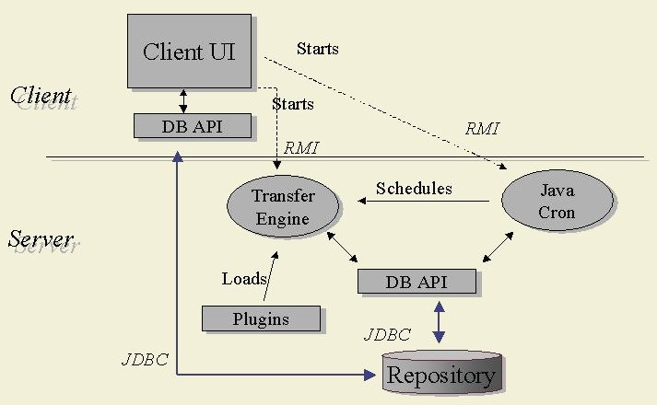
Figure 1 Dagger components and their interactions

Dagger components
Dagger consists of following main components:
- GUI Client application through which user can alter Dagger’s repository and run the engine
- Transfer Engine that is the central component of the system; it executes operations defined in the repository
- Rock (DB API in the Figure 1) that provides access to databases and performs mapping of objects to database tables and vice versa
- Scheduler (Java Cron) that prompts the Engine to execute given tasks at specific time
- Plugins a set of plug-in classes allowing operations on various data sources
- Repository stores all definition of transfers, scheduling details and other information required by Dagger to perform transfers (e.g. database connection definitions)

Component descriptions

User interface
User interface provides a convenient way to create, manipulate and use repository content. In a typical use case a user creates a metadata version, transfer groups and transfer sets. Then it is possible to define desired transfer operations on data (taken for example from a database, file or any other source supported by plug-ins). After specifying all the transfers user can start the transfer engine manually and execute the transfers immediately. But it is also possible to use the java cron and schedule actions to take place in the future – only once at specified time or many times in defined intervals.
From the system point of view the UI contains the main window with menu allowing to perform key operations of the system (e.g. creation of a new transfer group or change of existing one). The main window is connected with many small dialog windows, which group similar functionality in one place. For example when a new connection is created, a new dialog window opens and lists all already existing connections, additionally it allows defining a new connection, editing connection’s settings and finally, deleting a connection. Often also sub-windows of the main windows have other sub-windows.
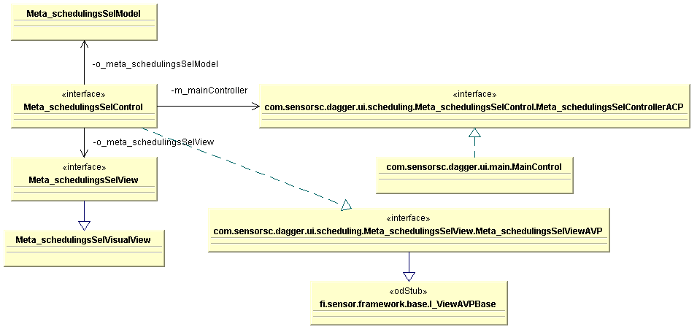
Figure 2 UI architecture example
The architecture of user interface is based on MVC (Model View Controller) style. Therefore almost all visual elements have a corresponding controller and model (see Figure 2). For example the scheduling dialog window is created by following classes: Meta_schedulingsSelVisualView, Meta_schedulingsSelView that hold all visual components and they are part of the view, Meta_schedulingsSelControl that controls the scheduling element and is the controller Meta_schedulingsSelModel that holds data for the element and is the model. It is easy to find and modify a class that is responsible for behaviour, data or visual representation; this is possible because of the naming convention of the classes that have –VisualView, -View; -Control or –Model suffixes for view, controller and model respectively. For example to change behaviour of the Detail button in the Scheduling page user should modify the detailButton method in the Meta_schedulingsSelControl class.
NOTE: The naming used in the code differs from that used in the updated UI. All references in the UI to “transfer group” refer, in the code, to “collection set” and “transfer set”, in the UI, refers to a “collection”, in the code.

Engine
The transfer engine is the central component responsible for the essential actions taken in the system. It performs transformations defined in a repository. Engine can use as a source, or target, a database, file or any other source of data that is supported by installed plug-ins. This way it is a very flexible and powerful tool for ETL operations. The engine is remotely accessed using Java RMI.
The ITransferEngineRMI provides remote access to main functions of the engine, particularly to the execute methods that allow selecting transfer groups (former collection sets) and transfer sets (former collections) to execute transfers. This interface has also methods to obtain details about installed plug-ins (see Figure 3). The TransferEngine class implements the ITransferEngine interface and is responsible for starting the EngineThread, which performs execution of selected transformations. This implementation also takes care that a specified limit of concurrently running threads is not exceeded and that there are not two running threads for the same transfer group and transfer set.
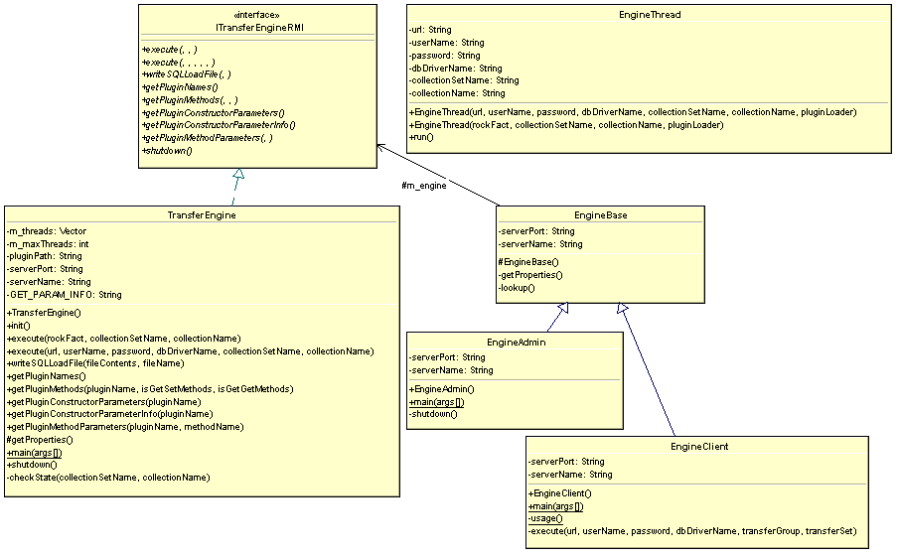
Figure 3 Transfer Engine
The EngineAdmin extending the EngineBase abstract class is used for starting and stopping the engine. The EngineClient class is used as a command line client to access the engine; it allows a user to start manually selected transformations.
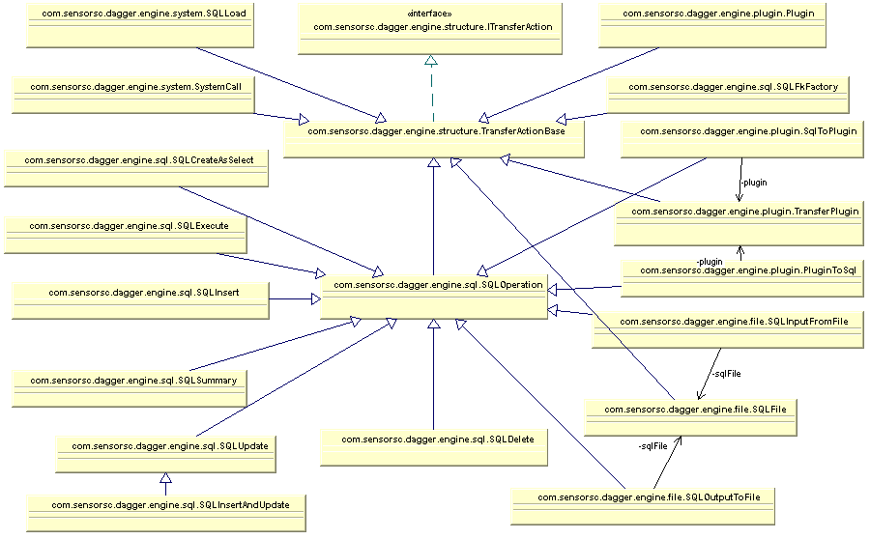
Figure 4 Main engine classes – inheritance
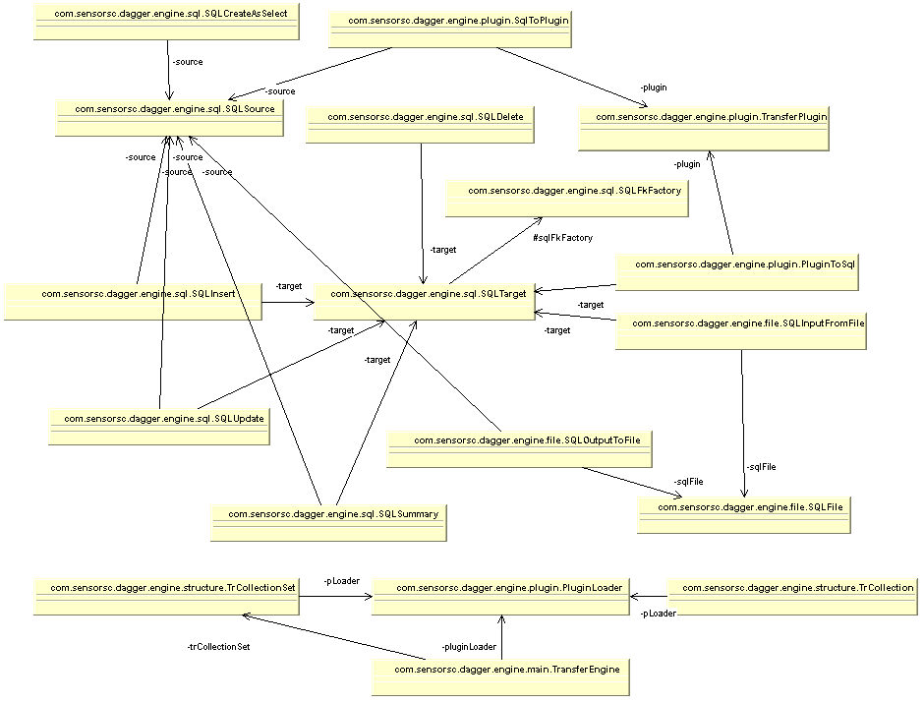
Figure 5 Main engine classes – relations

The TransferActionBase class, which implements the ITransferAction interface, is the central class that is extended by classes that represent transfer actions performed by the engine (see Figure 4). The transfers can be categorised as: SQL operations, system related and plug-ins.

Scheduler
The DaggerCron is a scheduling class responsible for executing given transformations at specified time. It also allows remote access so that a client can add new transformation to the schedule.
The DaggerCron class implements the IDaggerCronRMI interface, which exposes methods used for scheduling to the client (see Figure 6). The CronThread checks which ExecutionObjects should be run at given time and if the current time is the time of execution of given ExecutionObject it is executed along with all its nested objects.
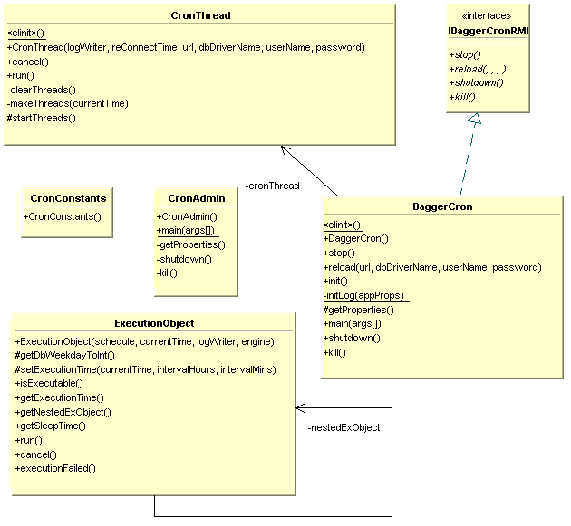
Figure 6 Scheduler

Exp and imp
Export and import tools are designed to export a selected metadata version and all its transfer groups and transfer sets, or to export a smaller part of a repository for example only specific transfer group (and its transfer sets) or only a selected transfer set. The exported data is exported as an XML file. This way it is easy to move data between repositories.
These tools were designed with the intention to improve maintenance of a system on the client side. The client’s repository can be exported in order to improve defined transformation in a test environment and then imported back to the client repository. Because during the import process it is possible to preserve database connections settings (providing that database connection names are the same in client and test environment), the database in the test environment can be completely independent from the production (client) database.
The export tool, DaggerExporter class (see Figure 7), allows performing export operations from the command line. The import tool, DaggerImporter class, allows performing import operations. Both classes extend the DaggerXporterBase class, which provides common methods for validation parameters, exception handling and obtaining access to the rock engine.
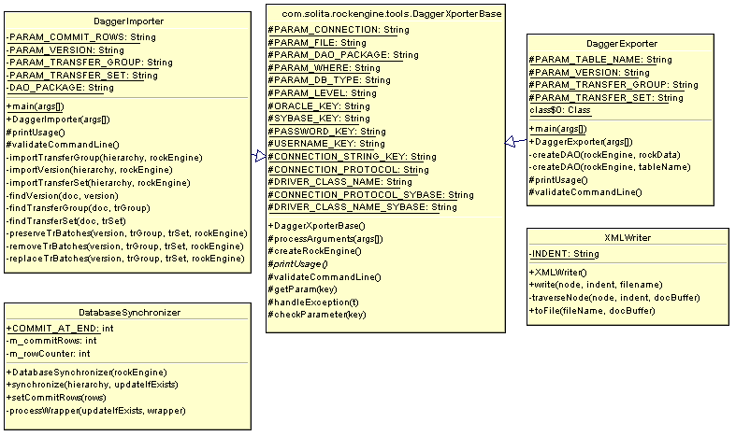
Figure 7 Exporter and Importer
Both export and import tools use DAO classes generated for each table in the repository. In case of exporting, the DAO objects are populated with data from the repository and then transformed into XML code. When data is imported, the XML code is transformed into DAO objects and then inserted to the repository database. If in the target repository already exists metadata version, transfer group or transfer set with names as those imported, the existing repository elements will be deleted prior to the import operation. If there is imported only a part of metadata version (e.g. a transfer set), in the target repository must already exist metadata version and transfer group, where the imported transfer set belongs.
The XMLWriter class is used by the exporter to create XML code from DAO objects. The DatabaseSynchronizer class is used in the importer tool to synchronise the repository database with the imported data. The synchronisation is done by inserting the imported data to the repository.

Rock
The Rock component allows manipulation of database content in object-orientated manner. Each database table is represented as a DAO object with getter and setter methods, as well as methods for inserting, updating and deleting data. The DAO objects represent also relations between tables in the database, so for example a cascade delete is performed if a given table has dependent tables.
There is also another version of rockengine (version 2.2) used by the import and export tools. This rock version is not used by Dagger itself directly, however DAO classes representing the repository, which are used in import/export operations, were generated with this version. It is also important that both rock versions cannot be replaced or mixed; therefore build scripts for import/export tools are separated from the main build script.

Plug-ins
Dagger supports a number of plug-ins that can be used to import or export data to/from a database. The plug-ins that import data to a database from a data source should implement the PluginReadClass interface. This interface provides two methods that should be defined in the implementing class. One method is next(), which sets the next element to be read, the other method is hasNext(), which tests whether there exists another element to read.
Plug-ins that export data from the database should implement the PluginWriteClass interface. This interface defines two methods: addRow(), which should be used to add another row to the output document, and commit() which commits changes.
For other types of plug-ins the PluginClass interface should be implemented. It has only one method commit(), which commits changes.
There are some of the plug-ins already implemented in the system. For example:
  - FtpPlug – used for ftp transfer of files
  - HttpPlug – used for http transfer of files
  - XMLGetPlug – used to read data from XML files to database
  - XMLWritePlug – used to write data from database to a file in XML format
Plug-in classes are dynamically loaded at run time; therefore plug-ins can be added to the system, as they are needed.
Note: All classes implementing one of the mentioned plug-in interfaces must comply with the naming convention and each class name must end with the “Plug” suffix.

Package structure
The package group classes according to functionality and layer of the application:
com.sensorsc.dagger – security manager for Dagger
com.sensorsc.dagger.cron – Cron related classes
com.sensorsc.dagger.engine.common – Common classes, for example exceptions
com.sensorsc.dagger.engine.connect – Database connection
com.sensorsc.dagger.engine.file – Classes related to operations on files – reading/writing
com.sensorsc.dagger.engine.main – Main engine classes including engine thread and interface used in RMI connections
com.sensorsc.dagger.engine.plugin – Plugin base classes
com.sensorsc.dagger.engine.sql – Clasees executing SQL operations
com.sensorsc.dagger.engine.structure – Base classes for collection set, collection and transfer action
com.sensorsc.dagger.engine.system – SQL Load and system call executing in the system shell
com.sensorsc.dagger.rock – The rock classes; classes representing repository tables
com.sensorsc.dagger.ui.batch – Classes related to the Transfer batches window
com.sensorsc.dagger.ui.collection – Classes related to collections (transfer sets) tables
com.sensorsc.dagger.ui.common – General classes used in UI
com.sensorsc.dagger.ui.common.renderer – Renderer classes used to render for example table cells
com.sensorsc.dagger.ui.copy – Classes used by the copy dialog window
com.sensorsc.dagger.ui.database – database related classes; for example classes used by connection dialog window
com.sensorsc.dagger.ui.joint – Classes used in the joints table
com.sensorsc.dagger.ui.login – Classes used in the login dialog window
com.sensorsc.dagger.ui.main – The main window related classes
com.sensorsc.dagger.ui.model – Model classes for files, SQL load and plug-ins
com.sensorsc.dagger.ui.parameter – Classes used in the parameters dialog window
com.sensorsc.dagger.ui.scheduling – Classes used in the scheduling dialog
com.sensorsc.dagger.ui.sqlload – Classes related to SQL Load dialog window
com.sensorsc.dagger.ui.transformation – Classes used in the transformation dialog window
com.sensorsc.dagger.ui.version – Classes used in the Metadata version selection dialog window

Repository

Tables description
Dagger’s repository stores all the information needed for the Dagger to perform transfers. The repository can be selected at login, by providing connection parameters.
The main repository tables are:
META_VERSIONS – contains details about metadata versions
META_COLLECTION_SETS – contains details about transfer groups (former collection sets)
META_COLLECTIONS – contains details about transfer sets (former collections)
META_TRANSFER_ACTIONS – contains details about transfer actions; the actual actions to be performed on data are defined in this table
META_PARAMETERS – contains metadata version parameters (e.g. email address to send notification in case of failures)
META_TRANSFORMATION_RULES – contains definitions of transformations
META_SOURCE_TABLES – contains identifiers of source tables involved in transfer actions
META_TARGET_TABLES – contains identifiers of target tables involved in transfer actions
META_JOINTS – contains definitions of table joints used in transfers
META_CONNECTION_TYPES – contains definitions of supported connection types (e.g. JDBC, Oracle JDBC or Oracle DB link)
META_DATABASES – contains details of database connections used in transformations
META_TABLES – contains parameters of all tables found in the databases defined in the META_DATABASES table
META_COLUMNS – contains details of columns that belong to tables defined in the META_TABLES table
META_FK_TABLE_JOINTS – contains foreign keys definitions used in joints
META_DEBUGS – details of transfer action executions
META_FILES – details of files that are used to import data to a database
META_COLUMN_CONSTRAINTS – defines constraints impose on certain column
META_TRANSF_TABLE_VALUES – contains transformation table values used in transformations
META_PARAMETER_TABLES – additional parameters definitions
META_TRANSFORMATION_TABLES – contains details of tables used in transformations
META_SCHEDULINGS – contains scheduling definitions used by the Cron to perform transfers at defined times
META_TRANSFER_BATCHES – contains statues of batch actions; details can be checked from the META_DEBUGS table
META_ERRORS – contains error messages registered during transfer action execution
META_PLUGINS – contains details of plug-ins used in transfer actions
META_STATUSES – contains statues of transfer batches execution
META_FK_TABLES – contains details about foreign keys
META_SQL_LOADS – contains details (e.g. source file and control file) used in SQL loads

Tables references
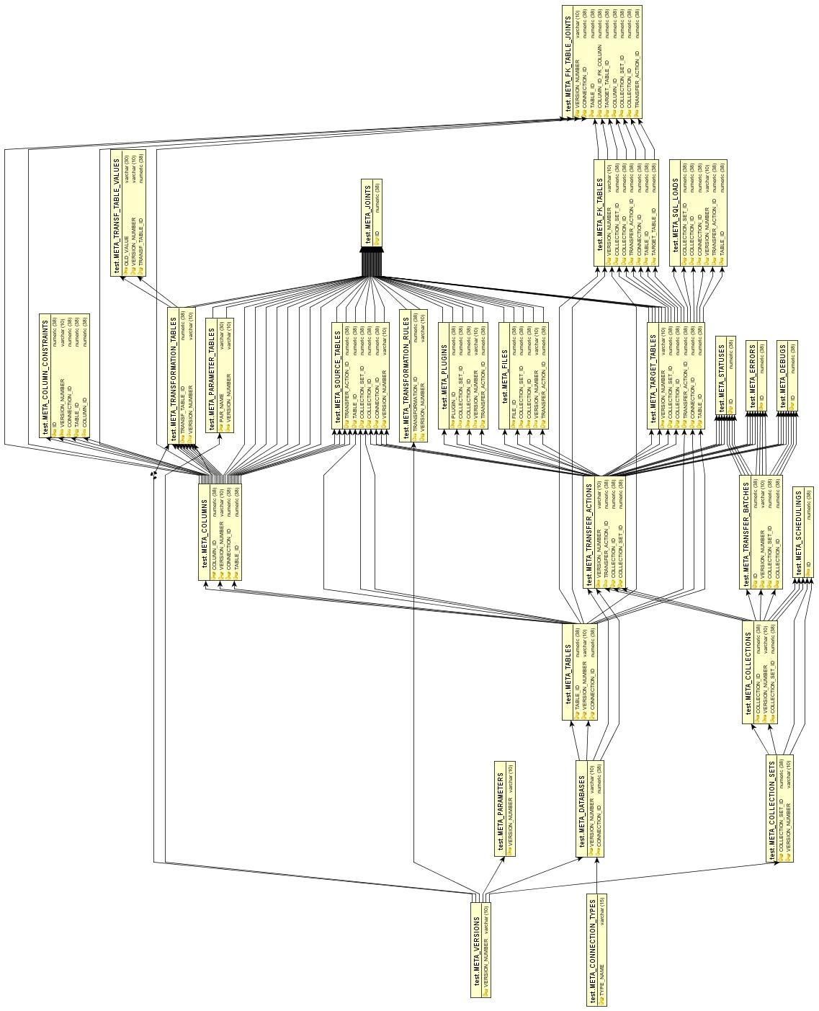
Figure 8 Database table references

Environment description

Directories
The directory structure is as follows:
  - the main Dagger’s directory contains:
    - bin directory with compiled classes
    - deploy directory with deployable files (ready to work Dagger)
    - impl directory with the source code and configuration settings
    - doc directory with the documentation (including this document)
    - exporter directory with the export and import tools
    - rockengine_2_2
  - the bin directory structure is the same as structure of packages, which was described in point 3.7
  - the deploy directory has following sub directories:
    - confservice directory contains configuration files (e.g. database connection format definitions)
    - lib directory contains libraries (jar files) used by or being part of Dagger (e.g. database drivers or the engine)
    - plugins directory contains plug-in classes
    - release directory contains installable version of Dagger
    - run directory contains scripts used to start Dagger’s components: GUI, engine or cron; e.g. the startEngine.bat starts the engine in Windows, the startGui.bat starts the GUI of Dagger in Windows and the Start_Cron.bat starts the cron in Unix system. In general scripts with an underscore ‘_’ indicates that the script should be used in Unix system, while those without an underscore should be used in Windows system.
    - sql directory has two subdirectories – oracle and sybase they contain scripts used to create a new repository in specific database
  - the impl directory has following subdirectories:
    - api directory contains javadoc documentation on the engine and cron classes
    - lib directory contains jar files needed to correctly compile Dagger source files, this directory also contains some resources (e.g. icons used in the UI)
    - resources directory contains the help system used by the GUI
    - src directory contains java source files; the structure of subdirectories reflects the package structure, which is described in point 3.7
    - tools directory contains scripts used to build Dagger
  - the exporter directory has following structure:
    - rockengine directory which contains the rock engine used by the import/export tools; its structure is similar to the rockengine_2_2/rockengine directory structure with a difference that some classes are customised to meet exporter requirements (the modified classes are: com.solita.rockengine.tools.xport.DaggerImport, com.solita.rockengine.tools.xport.DaggerExport, com.solita.rockengine.tools.DaggerXporterBase)
  - the rockengine_2_2 directory contains following subdirectories:
    - rockengine directory with the rockengine 2.2
    - jagger directory with the Jagger used to generate DAO objects
  - the rockengine directory contains following subdirectories
    - api with javadoc documents on the API of the rock
    - build with scripts used to build the rock and export/import tools
    - classes with compiled classes
    - doc with documents concerning this version of rock engine and the export/import tool
    - lib libraries (jar files) with external classes used by the rock (e.g. database drivers)
    - release with where ready to use rockengine is located
    - src where the source code is located
  - the jagger directory contains following subdirectories:
    - build with scripts used to build the Jagger
    - config with configuration files for Jagger (e.g. JDBC drivers names)
    - doc with documentation on Jagger and Rock
    - lib with libraries (jar files) used by the Jagger
    - release with executable jar file starting Jagger GUI
    - run with script files starting Jagger (startRockConverter.bat script)
    - src with the source code
    - templates with templates used to create methods in classes generated by Jagger
    - examples with some examples for Rock

Building and deploying
Dagger build environment was tested in the following configuration:
  - ant (Jakarta Ant) version 1.5
  - Java 1.3.x (jdk1.3.x)
In order to build Dagger, use the build script located in the “impl/tools” directory. This script has following tasks defined:
  - prepare – creates directories needed to perform a build operation correctly
  - compile – compiles Java source files
  - compileinstaller – compiles installer
  - remote – compiles classes needed for remote communication
  - gjar – creates a jar file with GUI
  - ejar – creates a jar file with engine, cron and rock classes
  - hjar – creates a jar files with help classes
  - deploy – copies the jar files to “deploy/lib” directory
  - all – it is a default task that depends on all above tasks and in the listed order
  - clean – this task removes files produces during compilation
  - rebuild – this task first calls the clean task and then the all task
  - javadoc – creates javadoc files for the engine and cron classes
After executing the default task (i.e. just calling the ant in the imp/tools directory) all files needed to start Dagger are located in the deploy directory. Dagger can be started by calling one of scripts located in the deploy/run directory (see 5.1).
In order to build the import/export tools it is enough to run the default target of the build.xml script located in the exporter\rockengine_2_2\build directory. Additionally this script has a target called dagger that copies export/import tools files to the deploy directory of Dagger.
The DAO objects used by import/export tools can be generated by the Jagger. Using its GUI user can specify a database which selected tables will be used for generating the DAOs. It is also possible to specify package names used for the generated classes. Among other parameters it is possible to specify whether the DAOs should use auto-generated IDs for use with the import/export tools this option should be disabled (the IDs already exist in the database and should not be changed, otherwise integrity of imported repository may be broken). More information on DAO generation can be found in: rockengine_2_2\jagger\doc\jagger_user_guide.doc .
Plug-in classes are located in the deploy/plugins directory this is also location of build.bat script that compiles the plug-in classes. Due to a dynamic nature of plug-ins they are not included in the main build script. Whenever a new plug-in is created and it requires some external classes, usually as a jar file, the classes must be declared in the plug-in build script as well as in the start engine script.

Dagger installation
The installation process consists of client and the engine installation, additionally it requires some configuration adjustments described below.

Client installation
a) copy the contents of the CD into the desired directory

Server (the engine) installation
a) create a database schema for Dagger repository
b) run the sql-script in deploy\sql\sybase\sybase_dagger.sql as the repository owner
c) define the following values in the deploy\run\daggerServer.properties:
- ENGINE_NAME = //[hostname]/[enginename], default value=//localhost/TransferEngine
- ENGINE_PORT = [portnumber], default value = 1099
- CRON_NAME = //[hostname]/[cronname], default value=//localhost/DaggerCron
- CRON_PORT = [portnumber], default value = 1099
d) add the startup of the engine in your server startup script (deploy\run\startEngine.bat)

Licenses
Dagger uses third party classes that are included in the distribution for the client’s convenience. Following libraries are not integral part of Dagger:
- classes12.zip, xmlparserv2.jar – Oracle license text located with the libraries
- jconn2.jar – Sybase license text located with the libraries
- commons-net-1.1.0.jar – Apache license located at http://www.apache.org/LICENSE-1.1

